

**RETAIL STORE STOCK INVENTORY ANALYTICS**

**NALAIYA THIRAN PROJECT BASED LEARNING**

**PROFESSIONAL READINESS FOR INNOVATION, EMPLOYABILITY, AND ENTREPRENEURSHIP**

**SUBMITTED BY**

Sivashankar T (727619BIT016)

Senthil Kumar S (727619BIT012)

Gunadeshwar A (727619BIT050)

Sampath Kumar M (727619BIT054)

**Bachelor of Technology**

**in**

**Information Technology**

**Dr. Mahalingam College of Engineering and Technology**

**Pollachi - 642003**

**An Autonomous Institution**

**Affiliated to Anna University, Chennai - 600 025**

**November 2022**

**Dr. Mahalingam College of Engineering and Technology**

**Pollachi - 642003**

**An Autonomous Institution**

**Affiliated to Anna University, Chennai -600 025**

**INTERNAL MENTOR**

J. Ramprasath,

Assistant Professor ,

Department of Information Technology,

Dr. Mahalingam College of Engineering and Technology,

Pollachi - 642003

**INDUSTRY MENTOR**

Shivani Kapoor

Rakesh Miskin

**RETAIL STORE STOCK INVENTORY ANALYTICS**

**ABSTRACT**

The inventory Management system handles the transactions revolving around the consumer’s goods. Without the proper inventory control, retail stores may run out of stock on some of the items in the shop. A good Inventory Management System will alert the retailer when it is time to refill the stock or will notify the retailer at the time of the stock when it is in low quantity. This is why integrating the right retail inventory management process is important to achieve smooth retail operations. When a retailer such as a grocery store is aught selling an expired product, they’ll have to pay a fine and face legal and compliance issues. Manually counting each pair of stocks is likely to result in an error. An automated inventory management system helps to minimize the risk of error. In retail stores, an Inventory Management System also helps track theft of retail merchandise, providing valuable information about store profits and the need for theft-preventions systems. The primary outcomes of this study are the leading inventory management systems and models, the Key Performance Indicators (KPIs) for their correct management, and the benefits and challenges of choosing or adopting an efficient inventory control and management system. The existing system consists of methods using ABC Analysis and Min-Max Analysis. In the Data Mart, the search for goods classes per subcategory is carried out using the ABC Analysis calculation method. For the future scope Inventory Management Systems have become more real-time, giving retailers more data about demographics, spending habits, shopping preferences, best-selling, etc. Good retail inventory management is essential to the success of any retail business. By putting in place effective systems and processes, businesses can ensure that they have the right level of stock to meet customer demand while also avoiding excessive levels of stock that can tie up valuable resources.

**TABLE OF CONTENTS**

**CHAPTER** **TITLE**  **PAGE NO**

**I.** Abstract 03

**II.** List of Figures 06

**1.** **INRODUCTION**

**1.1** Project Overview 07

**1.2**  Purpose 07

**2.** **IMPLEMENTATION & RESULT**

**2.1** Existing problem 08

**2.2** References 08

**2.3** Problem Statement Definition 08

**3.** **IDEATION & PROPOSED SOLUTION**

**3.1** Empathy Map Canvas 09

**3.2** Ideation & Brainstorming 10

**3.3** Proposed Solution 13

**3.4** Problem Solution fit 14

**4.** **REQUIREMENT ANALYSIS**

**4.1** Functional requirement 15

**4.2** Non-Functional requirements 16

**5.** **PROJECT DESIGN**

**5.1** Data Flow Diagrams 17

**5.2** Solution & Technical Architecture 18

**5.3** User Stories 19

**6.** **PROJECT PLANNING & SCHEDULING**

**6.1** Sprint Planning & Estimation 20

**6.2** Sprint Delivery Schedule 21

**6.3** Reports from JIRA 22

**7.** **CODING & SOLUTIONING**

**7.1** Feature 1 25

**7.2** Feature 2 28

**7.3** Display of Dashboard, Report and Story 32

**7.4** Database Schema: MySQL 36

**8.** **TESTING**

**8.1** Test Cases 37

**8.2** User Acceptance Testing 37

**9.** **RESULTS**

**9.1** Performance Metrics 38

**10.** **ADVANTAGES & DISADVANTAGES** 39

**11.** **CONCLUSION & FUTURE SCOPE** 40

**13.** **APPENDIX** 41

I. Source Code 41

II. GitHub & Project Demo Link 77

**LIST OF FIGURES**

**FIGURE NO** **FIGURE NAME**  **PAGE NO**

**2.1** Problem Statement 08

**3.1** Empathy Map 09

**3.2** Ideation & Brainstorming 10

**3.3** Proposed Solution 13

**3.4** Problem Solution fit 14

**5.1** Data Flow Diagrams 17

**5.2** Solution & Technical Architecture 18

**5.3** User Stories 19

**6.1** Sprint Planning & Estimation 20

**6.2** Sprint Delivery Schedule 21

**6.3** Reports from JIRA 22

**LIST OF TABLES**

**TABLE NO** **FIGURE NAME**  **PAGE NO**

**4.1** Functional requirement 15

**4.2** Non-Functional requirements 16

**CHAPTER 1**

**INTRODUCTION**

**1.1** **Project Overview**

Inventory Management is a technique through which stocked goods, inventories, and non-capitalized assets are kept properly according to their specific shape and placement. An Inventory can be any item that a business holds to receive the goal of resale or repair. Inventory Management is a process of ordering, storing, and using inventories. This stock management includes generating the lead on raw materials, components, and finished products, alongside warehousing and processing of such items in your company.

**1.2** **Purpose**

Data analytics initiatives can help businesses increase revenue, improve operational efficiency, optimize marketing campaigns and bolster customer service efforts. Analytics also enables organizations to respond quickly to emerging market trends and gain a competitive edge over business rivals. The ultimate goal of data analytics, however, is boosting business performance. Depending on the particular application, the data that's analyzed can consist of either historical records or new information that has been processed for real-time analytics. In addition, it can come from a mix of internal systems and external data sources. To ensure a continuous supply of materials and stock so that production should not suffer at the time of customer demand. To avoid both overstocking and under-stocking of inventory. To maintain the availability of materials whenever and wherever required in enough quantity.

To maintain minimum working capital as required for operational and sales activities. To optimize various costs indulged with inventories like purchase cost, carrying a cost, storage cost, etc. To keep material costs under control as they contribute to reducing the cost of production. To eliminate duplication in ordering stocks. To minimize loss through deterioration, pilferage, wastage, and damages. To ensure everlasting inventory control so that materials shown in stock ledgers should be physically lying in the warehouse. To ensure the quality of goods at reasonable prices. To facilitate the furnishing of data for short and long-term planning with a controlled inventory. To supply the required material continuously. To maintain a systematic record of inventory. To make stability in price.

**CHAPTER 2**

**IMPLEMENTATION & RESULT**

**2.1 Existing Problems**

The existing system consists of methods using ABC Analysis and Min-Max Analysis. In the Data Mart, the search for goods classes per subcategory is carried out using the ABC Analysis calculation method. Furthermore, in the Data Mart, the search for maximum and minimum stock values is based on the Min-Max Analysis calculation method. The resulting maximum and minimum grade and stock values are then implemented into the goods data table in the retail management information system database. The last stage is to arrange the order amount that is allowed in the order module in the retail management information system. Rules are made based on the class of goods along with the minimum and maximum stock values.

**2.2 References**

1. M Rusănescu 2014 Abc Analysis, Model for Classifying Inventory HIDRAULICA.
2. D Dhoka and Y L Choudary 2013 ABC Classification for Inventory Optimization IOSR J Bus Manage.
3. Funaki, K.., “Strategies safety stock placement in supply chain design with due-date based demand,” International Journal of Production Economics, vol. 135, pp 4-13, 2012.
4. Grewal, CS, Enns, ST, and Rogers, P., “Dynamic reorder point replenishment strategies for a capacitated supply chain with seasonal demand,” Computer, and industrial engineering, vol. .80, pp 97-110, 2015.

**2.3 Problem Statement Definition**

The main objective of the project is to manage the retail store because it contains large amounts of data and it is difficult for the retailer to keep track all the stocks and sales.

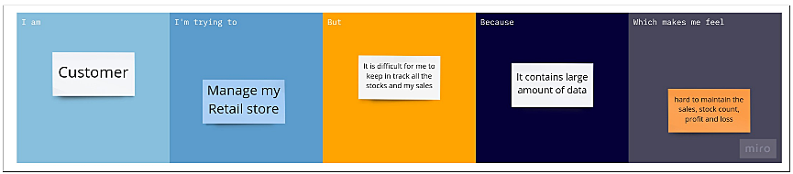

**Fig 2.1 Problem Statement**

**CHAPTER 3**

**IDEATION & PROPOSED SOLUTION**

**3.1 Empathy Map Canvas:**

An empathy map is a collaborative tool team can use to gain a deeper insight into their customers. Much like a user persona, an empathy map can represent a group of users, such as a customer segment. An Empathy Map consists of four quadrants. The four quadrants reflect four key traits, which the user demonstrated/possessed during the observation/research stage.

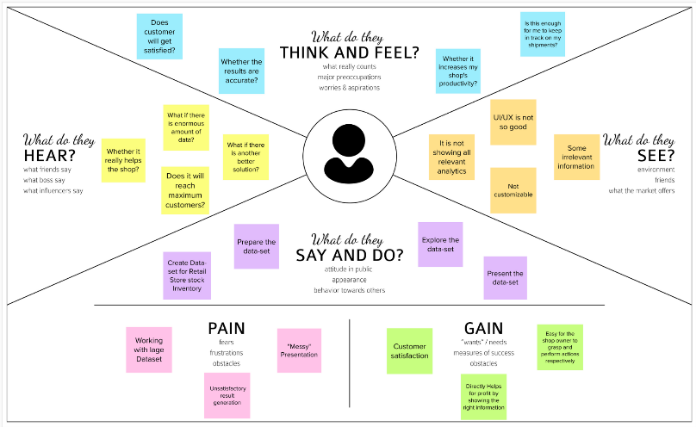

**Fig 3.1 Empathy Map**

**3.2 Ideation & Brainstorming:**

Brainstorming provides a free and open environment that encourages everyone within a team to participate in the creative thinking process that leads to problem-solving. Prioritizing volume over value, out-of-the-box ideas are welcome and built upon, and all participants are encouraged to collaborate, helping each other develop a rich number of creative solutions.

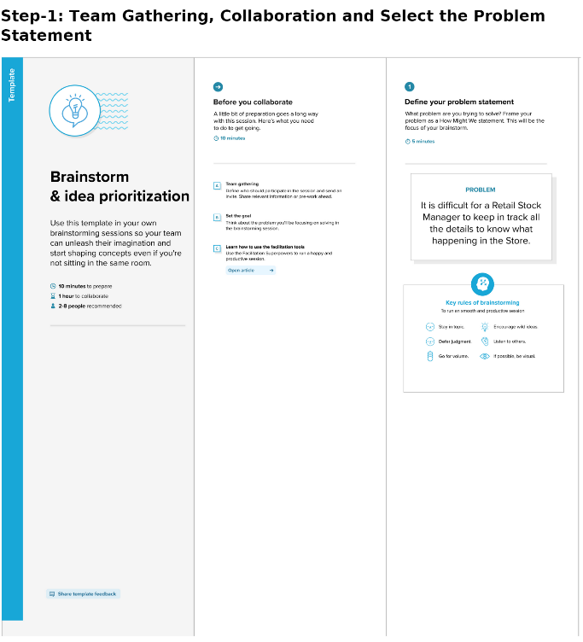

**Fig 3.2 Ideation & Brainstorming**

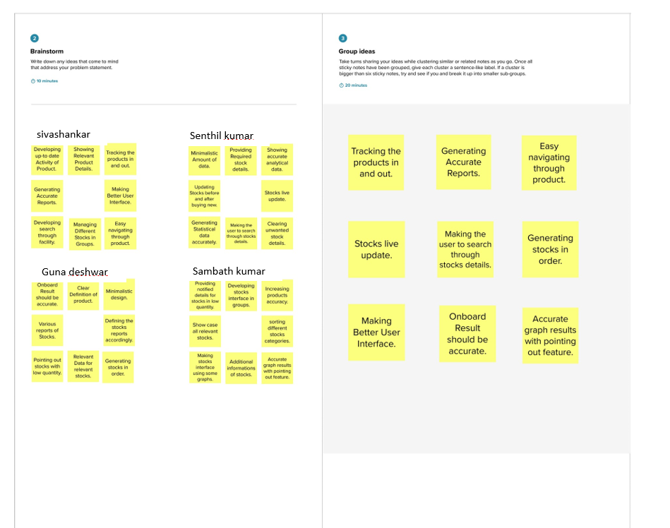

**Fig 3.2 Ideation & Brainstorming**

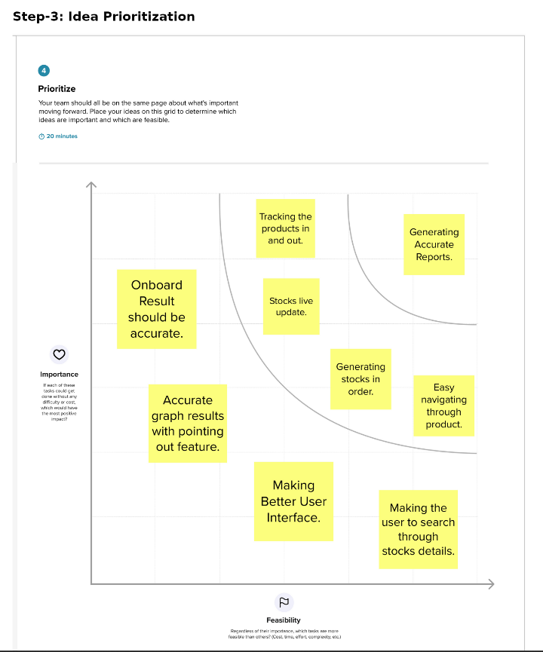

**Fig 3.2 Ideation & Brainstorming**

**3.3 Proposed Solution:**

Proposed Solution covers the Project's problem statement, idea description, Novelty, Social impact, Business Model, Scalability.

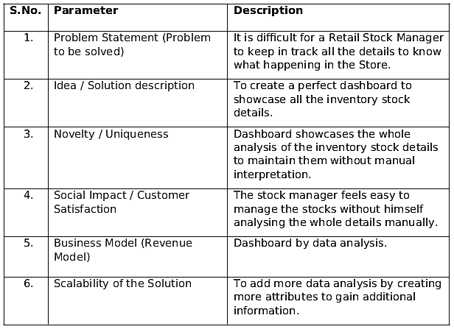

**Fig 3.3 Proposed Solution**

**3.4 Problem Solution fit:**

The Problem-Solution Fit simply means that you have found a problem with your customer and that the solution you have realized for it actually solves the customer's problem.

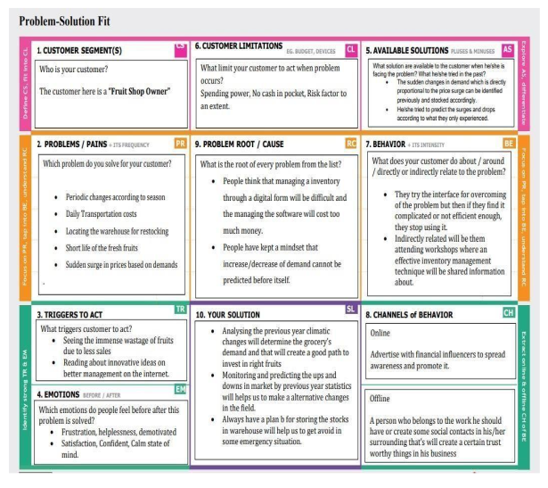

**Fig 3.4 Problem Solution Fit**

**CHAPTER 4**

**REQUIREMENT ANALYSIS**

**4.1 Functional requirement:**

Following are the functional requirements of the proposed solution:

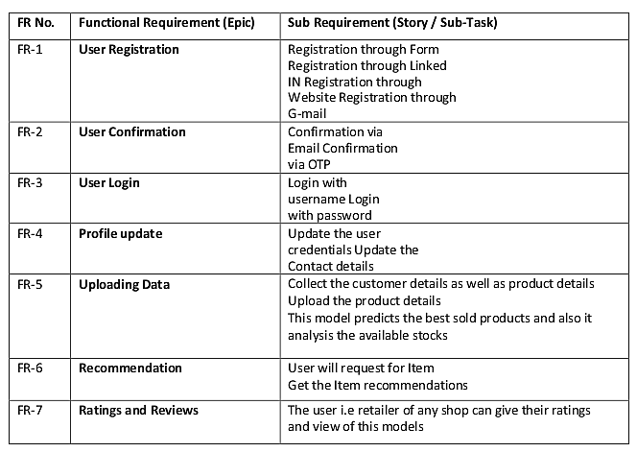

**Fig 4.1 Functional requirement**

**4.2 Non-Functional Requirements**

Following are the non-functional requirements of the proposed solution:

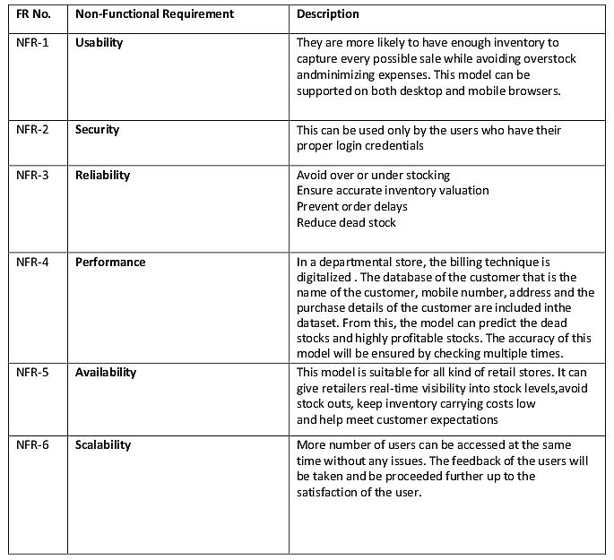

**Fig 4.2 Non-Functional requirement**

**CHAPTER 5**

**PROJECT DESIGN**

**5.1 Data Flow Diagrams:**

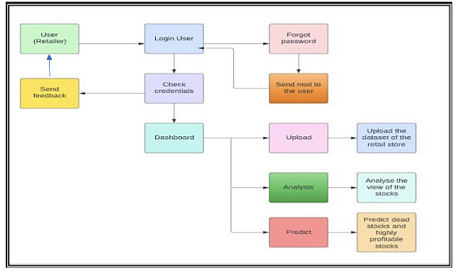

**Fig 5.1 Data Flow Diagrams**

**5.2 Solution & Technical Architecture:**

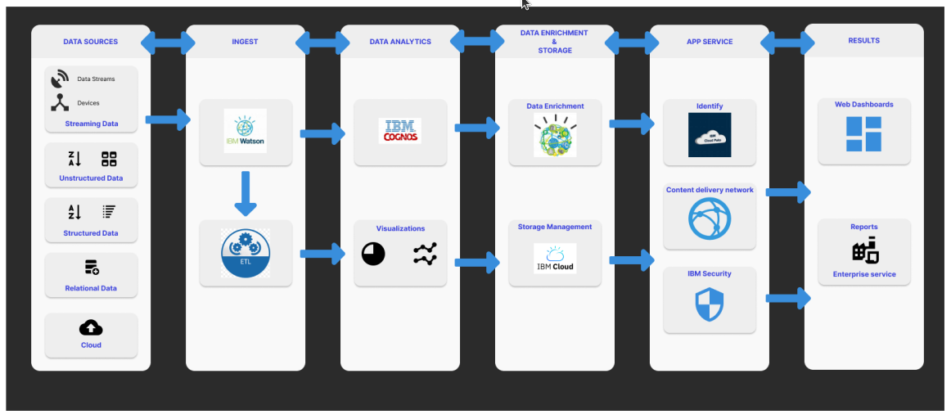

**Fig 5.2 Solution & Technical Architecture**

**Table-1 : Components & Technologies:**

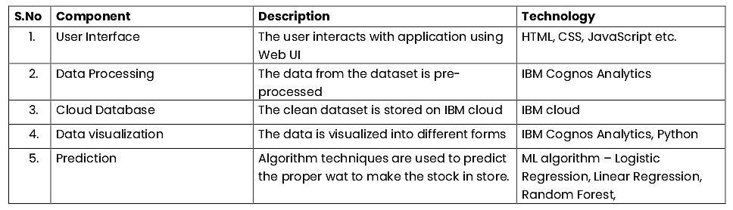

**Table-2: Application Characteristics:**

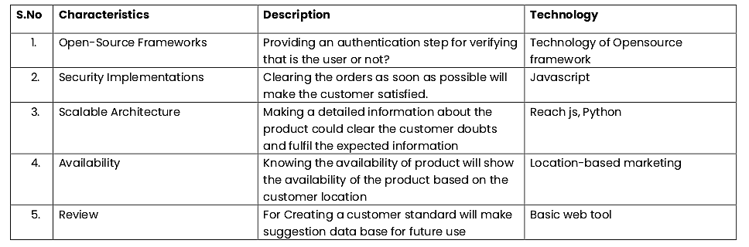

**5.3 User Stories:**

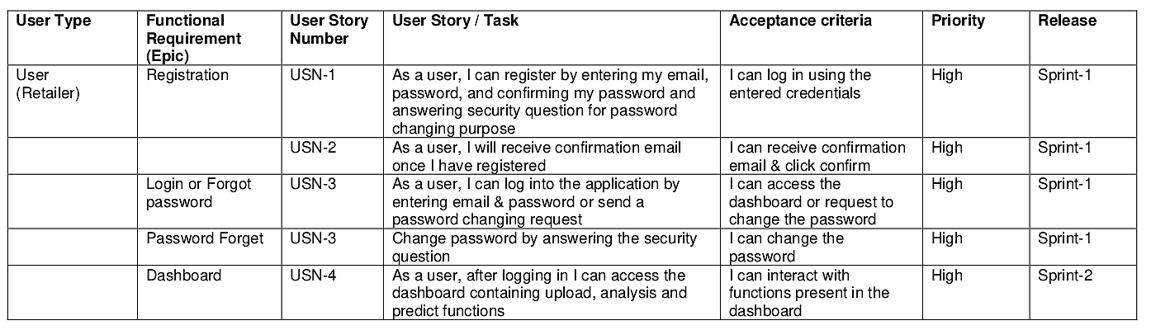

**Fig 5.3 User Stories**

**CHAPTER 6**

**PROJECT PLANNING & SCHEDULING**

**6.1 Sprint Planning & Estimation:**

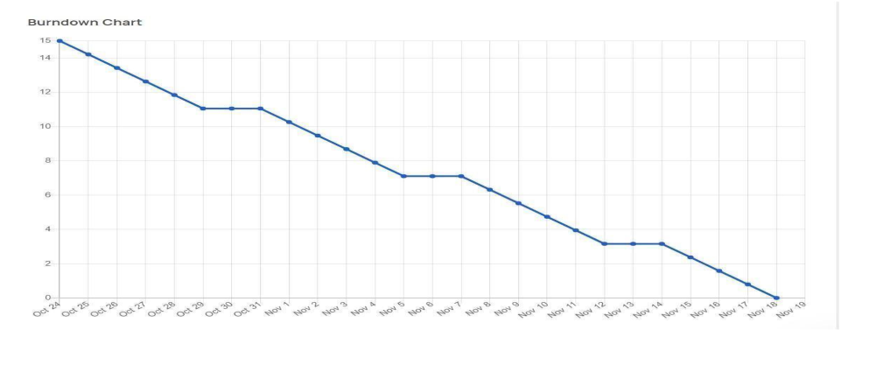

**Fig 6.1 Sprint Planning & Estimation**

**6.2 Sprint Delivery Schedule:**

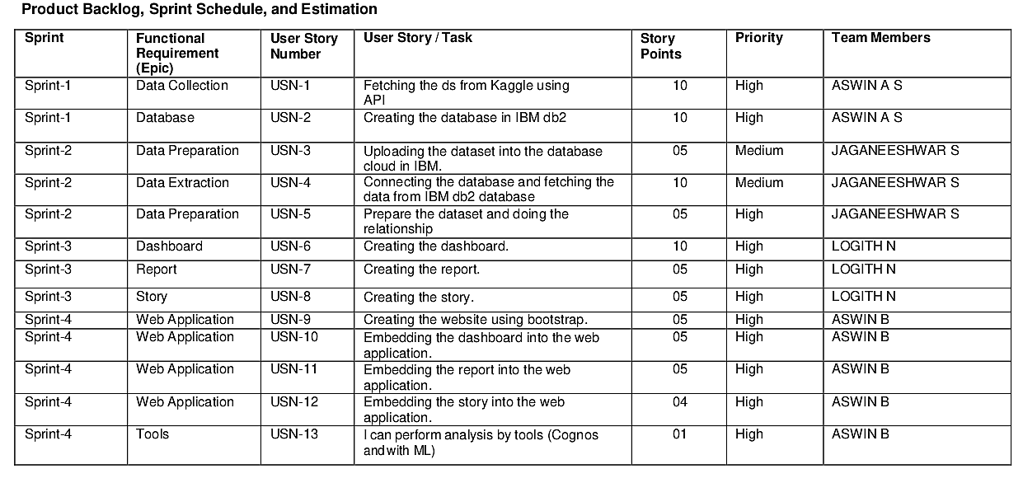

**Fig 6.2 Sprint Delivery Schedule**

**6.3 Reports from JIRA:**

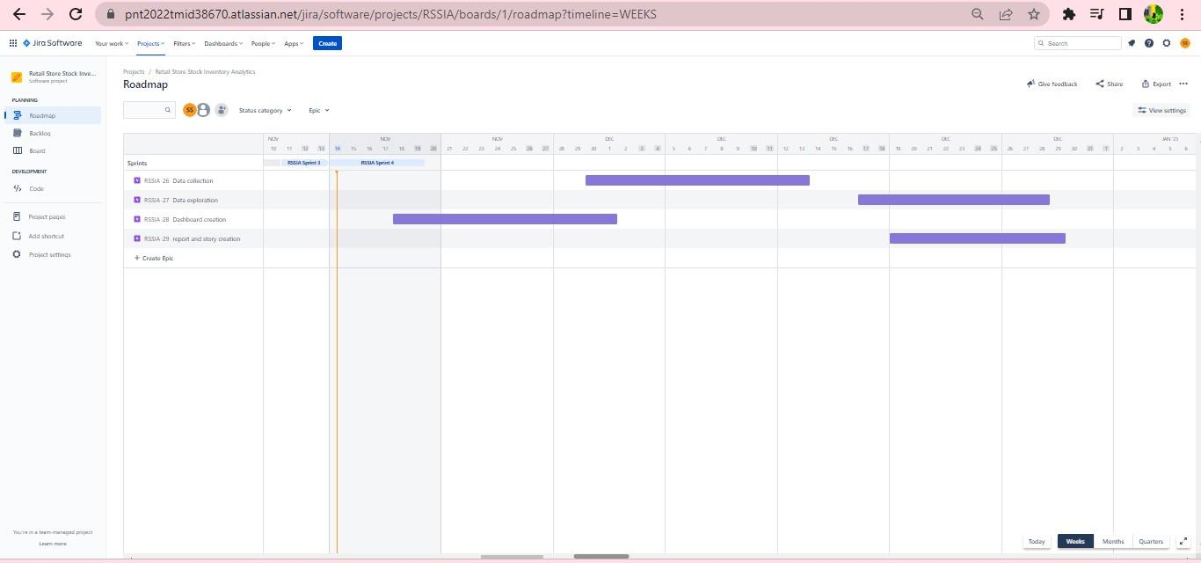

**Fig 6.3.1 Jira Project Planning**

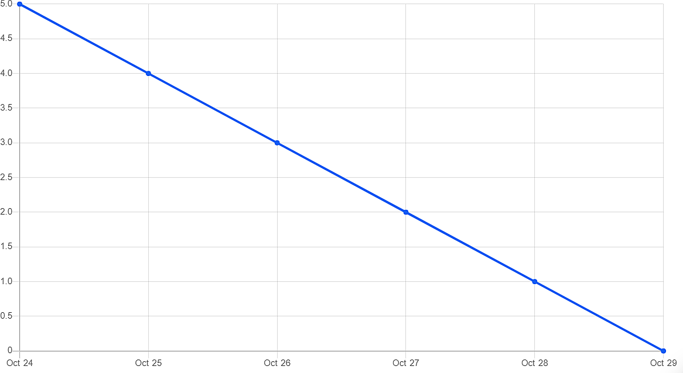

**Fig 6.3.2 Sprint 1**

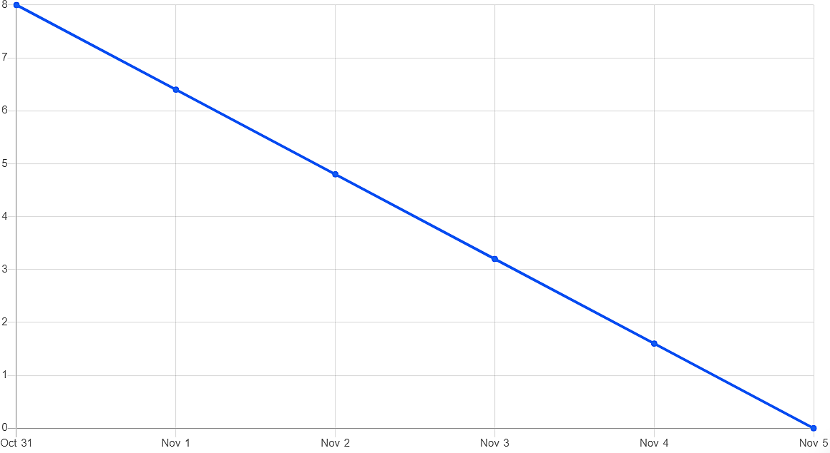

**Fig 6.3.3 Sprint 2**

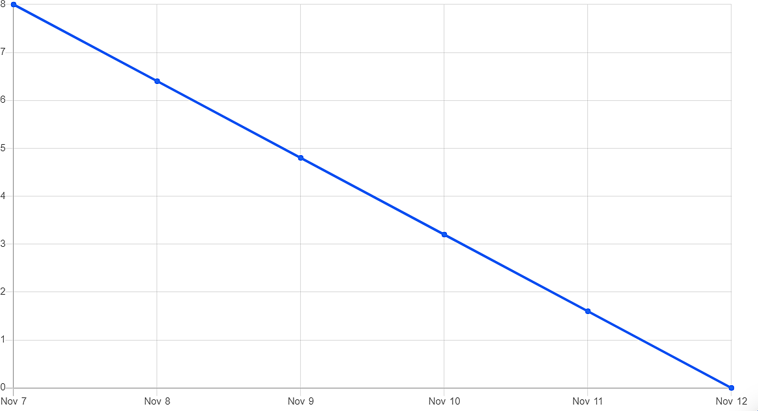

**Fig 6.3.4 Sprint 3**

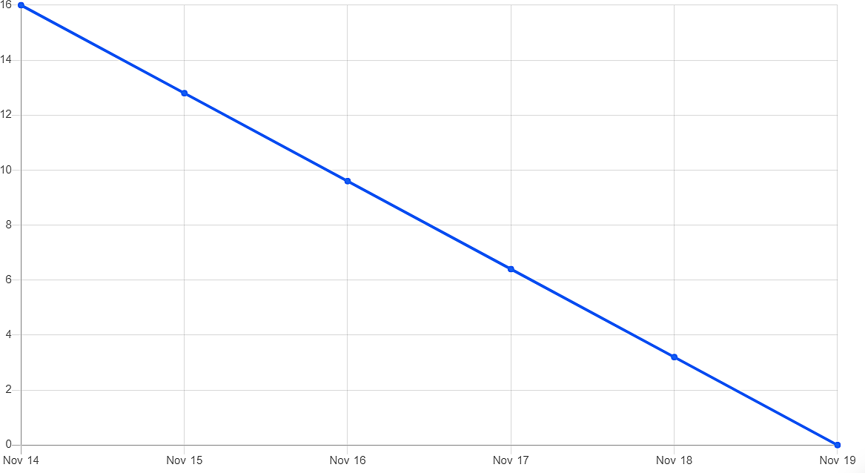

**Fig 6.3.5 Sprint 4**

**CHAPTER 7**

**CODING & SOLUTIONING**

**7.1 Feature 1: Login**

* Login page consist of Two fields:
  + Username
  + Password
* When a new user fill the username and password and clicks "login now" button available it shows alert message.
* When a registered user fill the username and password and click "login now" button available it redirects the user to the home page with container consisting of a welcome note along with the users name will be displayed.
* The feature which we have implemented in our login page is that, it will count the number of times the user has logged in and stores it it the database.

**Code:**

<?php include('server.php') ?><?php

?>

<!DOCTYPE html>

<html>

<head>

<meta charset="utf-8">

<meta name="viewport" content="width=device-width, initial-scale=1.0">

<link rel="stylesheet" href="https://stackpath.bootstrapcdn.com/font-awesome/4.7.0/css/font-awesome.min.css">

<link rel="stylesheet" type="text/css" href="styles.css">

<title>Login Form</title>

</head>

<body>

<div class="container">

<form action="login.php" method="POST" class="login-email">

<?php include('errors.php'); ?>

<p class="login-text" style="font-size: 2rem; font-weight: 800;">Login</p>

<div class="input-group">

<input type="text" placeholder="username" name="username" required>

</div>

<div class="input-group">

<input type="password" placeholder="Password" name="password" required>

</div>

<div class="input-group">

<button type="submit" class="btn" name="login_user">Login</button>

</div>

<p class="login-register-text">Don't have an account? <a href="register.php">Register Here</a>.</p>

</form>

</div>

</body>

</html>

**7.2 Feature 2: Registration**

* Registration page consist of four fields:
  + Username
  + Email
  + Password
* When a new user fill the login and click "login now" button it show a alert message, so that the user should sign up first.
* After that the user fills the registration form and clicks the "Sign up" button the user will be registered.
* Now the user will able to login to view the home page.

**Code:**

<?php

session_start();

if (isset($_GET['logout'])) {

session_destroy();

unset($_SESSION['username']);

header("location: login.php");

}

?><!DOCTYPE html>

<html lang="en">

<head>

<meta charset="utf-8">

<meta content="width=device-width, initial-scale=1.0" name="viewport">

<title>Dashboard</title>

<meta content="" name="description">

<meta content="" name="keywords">

<!-- Favicons -->

<link href="assets/img/favicon.png" rel="icon">

<link href="assets/img/apple-touch-icon.png" rel="apple-touch-icon">

<!-- Google Fonts -->

<link href="https://fonts.gstatic.com" rel="preconnect">

<link href="https://fonts.googleapis.com/css?family=Open+Sans:300,300i,400,400i,600,600i,700,700i|Nunito:300,300i,400,400i,600,600i,700,700i|Poppins:300,300i,400,400i,500,500i,600,600i,700,700i" rel="stylesheet">

<!-- Vendor CSS Files -->

<link href="assets/vendor/bootstrap/css/bootstrap.min.css" rel="stylesheet">

<link href="assets/vendor/bootstrap-icons/bootstrap-icons.css" rel="stylesheet">

<link href="assets/vendor/boxicons/css/boxicons.min.css" rel="stylesheet">

<link href="assets/vendor/quill/quill.snow.css" rel="stylesheet">

<link href="assets/vendor/quill/quill.bubble.css" rel="stylesheet">

<link href="assets/vendor/remixicon/remixicon.css" rel="stylesheet">

<link href="assets/vendor/simple-datatables/style.css" rel="stylesheet">

<!-- Template Main CSS File -->

<link href="assets/css/style.css" rel="stylesheet">

<!-- =======================================================

* Template Name: NiceAdmin - v2.4.1

* Template URL: https://bootstrapmade.com/nice-admin-bootstrap-admin-html-template/

* Author: BootstrapMade.com

* License: https://bootstrapmade.com/license/

======================================================== -->

</head>

<body>

<!-- ======= Header ======= -->

<header id="header" class="header fixed-top d-flex align-items-center">

<div class="d-flex align-items-center justify-content-between">

<a href="index.html" class="logo d-flex align-items-center">

<img src="assets/img/logo.png" alt="">

<span class="d-none d-lg-block">Retail store</span>

</a>

<i class="bi bi-list toggle-sidebar-btn"></i>

</div><!-- End Logo -->

<div class="search-bar">

<form class="search-form d-flex align-items-center" method="POST" action="#">

<input type="text" name="query" placeholder="Search" title="Enter search keyword">

<button type="submit" title="Search"><i class="bi bi-search"></i></button>

</form>

</div><!-- End Search Bar -->

<nav class="header-nav ms-auto">

<ul class="d-flex align-items-center">

<li class="nav-item d-block d-lg-none">

<a class="nav-link nav-icon search-bar-toggle " href="#">

<i class="bi bi-search"></i>

</a>

</li><!-- End Search Icon-->

<li class="nav-item dropdown">

<!-- End Notification Icon -->

<!-- <ul class="dropdown-menu dropdown-menu-end dropdown-menu-arrow notifications">

<li class="dropdown-header">

You have 4 new notifications

<a href="#"><span class="badge rounded-pill bg-primary p-2 ms-2">View all</span></a>

</li>

<li>

<hr class="dropdown-divider">

</li>

<li class="notification-item">

<i class="bi bi-exclamation-circle text-warning"></i>

<div>

<h4>Lorem Ipsum</h4>

<p>Quae dolorem earum veritatis oditseno</p>

<p>30 min. ago</p>

</div>

</li>

<li>

<hr class="dropdown-divider">

</li>

<li class="notification-item">

<i class="bi bi-x-circle text-danger"></i>

<div>

<h4>Atque rerum nesciunt</h4>

<p>Quae dolorem earum veritatis oditseno</p>

<p>1 hr. ago</p>

</div>

</li>

<li>

<hr class="dropdown-divider">

</li>

<li class="notification-item">

<i class="bi bi-check-circle text-success"></i>

<div>

<h4>Sit rerum fuga</h4>

<p>Quae dolorem earum veritatis oditseno</p>

<p>2 hrs. ago</p>

</div>

</li>

<li>

<hr class="dropdown-divider">

</li>

<li class="notification-item">

<i class="bi bi-info-circle text-primary"></i>

<div>

<h4>Dicta reprehenderit</h4>

<p>Quae dolorem earum veritatis oditseno</p>

<p>4 hrs. ago</p>

</div>

</li>

<li>

<hr class="dropdown-divider">

</li>

<li class="dropdown-footer">

<a href="#">Show all notifications</a>

</li>

</ul>End Notification Dropdown Items -->

</li><!-- End Notification Nav -->

<li class="nav-item dropdown">

<!-- <a class="nav-link nav-icon" href="#" data-bs-toggle="dropdown">

<i class="bi bi-chat-left-text"></i>

<span class="badge bg-success badge-number">3</span>

</a>End Messages Icon -->

<ul class="dropdown-menu dropdown-menu-end dropdown-menu-arrow messages">

<li class="dropdown-header">

You have 3 new messages

<a href="#"><span class="badge rounded-pill bg-primary p-2 ms-2">View all</span></a>

</li>

<li>

<hr class="dropdown-divider">

</li>

<li class="message-item">

<a href="#">

<img src="assets/img/messages-1.jpg" alt="" class="rounded-circle">

<div>

<h4>Maria Hudson</h4>

<p>Velit asperiores et ducimus soluta repudiandae labore officia est ut...</p>

<p>4 hrs. ago</p>

</div>

</a>

</li>

<li>

<hr class="dropdown-divider">

</li>

<li class="message-item">

<a href="#">

<img src="assets/img/messages-2.jpg" alt="" class="rounded-circle">

<div>

<h4>Anna Nelson</h4>

<p>Velit asperiores et ducimus soluta repudiandae labore officia est ut...</p>

<p>6 hrs. ago</p>

</div>

</a>

</li>

<li>

<hr class="dropdown-divider">

</li>

<li class="message-item">

<a href="#">

<img src="assets/img/messages-3.jpg" alt="" class="rounded-circle">

<div>

<h4>David Muldon</h4>

<p>Velit asperiores et ducimus soluta repudiandae labore officia est ut...</p>

<p>8 hrs. ago</p>

</div>

</a>

</li>

<li>

<hr class="dropdown-divider">

</li>

<li class="dropdown-footer">

<a href="#">Show all messages</a>

</li>

</ul><!-- End Messages Dropdown Items -->

</li>

<li class="nav-item dropdown pe-3">

<a class="nav-link nav-profile d-flex align-items-center pe-0" href="#" data-bs-toggle="dropdown">

<img src="assets/img/1.jpg" alt="Profile" class="rounded-circle">

<span class="d-none d-md-block dropdown-toggle ps-2"><?php $_SESSION['username']?></span>

</a><!-- End Profile Iamge Icon -->

<ul class="dropdown-menu dropdown-menu-end dropdown-menu-arrow profile">

<li class="dropdown-header">

<h6> <?php echo $_SESSION['username']; ?></h6>

<span></span>

</li>

<li>

<hr class="dropdown-divider">

</li>

<li>

<a class="dropdown-item d-flex align-items-center" href="users-profile.php">

<i class="bi bi-person"></i>

<span>My Profile</span>

</a>

</li>

<li>

<hr class="dropdown-divider">

</li>

<li>

<a class="dropdown-item d-flex align-items-center" href="users-profile.html">

<i class="bi bi-gear"></i>

<span>Account Settings</span>

</a>

</li>

<li>

<hr class="dropdown-divider">

</li>

<li>

<a class="dropdown-item d-flex align-items-center" href="pages-faq.html">

<i class="bi bi-question-circle"></i>

<span>Need Help?</span>

</a>

</li>

<li>

<hr class="dropdown-divider">

</li>

<li>

<a class="dropdown-item d-flex align-items-center" href="<?php if($_SESSION['username']){

echo "login.php";}?>">

<?php if(!$_SESSION['username']){?>

<i class="bi bi-box-arrow-right"></i>

<span>

<?php echo"Login";?></span>

<?php }else{?>

<i class="bi bi-box-arrow-right"></i>

<?php echo"Logout";

}?>

</a>

</li>

</ul><!-- End Profile Dropdown Items -->

</li><!-- End Profile Nav -->

</ul>

</nav><!-- End Icons Navigation -->

</header><!-- End Header -->

<!-- ======= Sidebar ======= -->

<aside id="sidebar" class="sidebar">

<ul class="sidebar-nav" id="sidebar-nav">

<li class="nav-item">

<a class="nav-link " href="index.php">

<i class="bi bi-grid"></i>

<span>Dashboard</span>

</a>

</li>

<li class="nav-item">

<a class="nav-link " href="Report.php">

<i class="bi bi-bookmark"></i>

<span>Report</span>

</a>

</li><!--End Dashboard Nav -->

<li class="nav-item">

<a class="nav-link " href="story.php">

<i class="bi bi-camera-video"></i>

<span>Story</span>

</a>

</li>

<li class="nav-heading">Pages</li>

<li class="nav-item">

<a class="nav-link collapsed" href="users-profile.php">

<i class="bi bi-person"></i>

<span>Profile</span>

</a>

</li><!-- End Profile Page Nav -->

<li class="nav-item">

<a class="nav-link collapsed" href="contact.php">

<i class="bi bi-envelope"></i>

<span>Contact</span>

</a>

</li><!-- End Contact Page Nav -->

<li class="nav-item">

<a class="nav-link collapsed" href="pages-register.html">

<i class="bi bi-card-list"></i>

<span>About</span>

</a>

</li><!-- End Register Page Nav -->

<li class="nav-item">

<a class="nav-link collapsed" href="index.php?logout='1'\">

<i class="bi bi-box-arrow-in-right"></i>

<?php if(!$_SESSION['username']){?>

<i class="bi bi-question-circle"></i>

<span>

<?php echo"Login";?></span>

<?php }else{echo"Logout";

}?>

</a>

</li><!-- End Login Page Nav -->

</ul>

</aside><!-- End Sidebar-->

<main id="main" class="main">

<div class="pagetitle">

<h1>Story</h1>

<nav>

<ol class="breadcrumb">

<li class="breadcrumb-item"><a href="index.html">Home</a></li>

<li class="breadcrumb-item active">Story</li>

</ol>

</nav>

</div><!-- End Page Title -->

<section class="section dashboard">

<div class="row">

<!-- Left side columns -->

<div class="col-lg-8">

<div class="row">

</div>

</div><!-- End Left side columns -->

<!-- -->

<iframe src="https://us3.ca.analytics.ibm.com/bi/?perspective=story&amp;pathRef=.my_folders%2FRetail%2BStore%2BInventory%2BStory&amp;closeWindowOnLastView=true&amp;ui_appbar=false&amp;ui_navbar=false&amp;shareMode=embedded&amp;action=view&amp;sceneId=model000001848a560f0d_00000000&amp;sceneTime=0" width="1000" height="600" frameborder="0" gesture="media" allow="encrypted-media" allowfullscreen=""></iframe>

</section>

</main><!-- End #main -->

<!-- ======= Footer ======= -->

<footer id="footer" class="footer">

<div class="copyright">

&copy; Copyright <strong><span>Retail Stockers</span></strong>. All Rights Reserved

</div>

<div class="credits">

<!-- All the links in the footer should remain intact. -->

<!-- You can delete the links only if you purchased the pro version. -->

<!-- Licensing information: https://bootstrapmade.com/license/ -->

<!-- Purchase the pro version with working PHP/AJAX contact form: https://bootstrapmade.com/nice-admin-bootstrap-admin-html-template/ -->

Designed by <a href="https://bootstrapmade.com/">GD</a>

</div>

</footer><!-- End Footer -->

<a href="#" class="back-to-top d-flex align-items-center justify-content-center"><i class="bi bi-arrow-up-short"></i></a>

<!-- Vendor JS Files -->

<script src="assets/vendor/apexcharts/apexcharts.min.js"></script>

<script src="assets/vendor/bootstrap/js/bootstrap.bundle.min.js"></script>

<script src="assets/vendor/chart.js/chart.min.js"></script>

<script src="assets/vendor/echarts/echarts.min.js"></script>

<script src="assets/vendor/quill/quill.min.js"></script>

<script src="assets/vendor/simple-datatables/simple-datatables.js"></script>

<script src="assets/vendor/tinymce/tinymce.min.js"></script>

<script src="assets/vendor/php-email-form/validate.js"></script>

<!-- Template Main JS File -->

<script src="assets/js/main.js"></script>

</body>

</html>

**7.3 Feature 3: Display of Dashboard, Report and Story**

* After the user has successfully registered and login the user will be redirected to the home page with welcome note "Welcome toAccount" along with the username.
* The home page consist of 4 buttons
  + Story
  + Report
  + Dashboard
  + Logout
* Based on the user preference they can view the story,report and dashboard by clicking on the respective buttons.
* After viewing the required preferences the user can leave the webpage by clicking the "Logout" button available in the home page.

**Code:**

<?php

session_start();

if (isset($_GET['logout'])) {

session_destroy();

unset($_SESSION['username']);

header("location: login.php");

}

?><!DOCTYPE html>

<html lang="en">

<head>

<meta charset="utf-8">

<meta content="width=device-width, initial-scale=1.0" name="viewport">

<title>Dashboard</title>

<meta content="" name="description">

<meta content="" name="keywords">

<!-- Favicons -->

<link href="assets/img/favicon.png" rel="icon">

<link href="assets/img/apple-touch-icon.png" rel="apple-touch-icon">

<!-- Google Fonts -->

<link href="https://fonts.gstatic.com" rel="preconnect">

<link href="https://fonts.googleapis.com/css?family=Open+Sans:300,300i,400,400i,600,600i,700,700i|Nunito:300,300i,400,400i,600,600i,700,700i|Poppins:300,300i,400,400i,500,500i,600,600i,700,700i" rel="stylesheet">

<!-- Vendor CSS Files -->

<link href="assets/vendor/bootstrap/css/bootstrap.min.css" rel="stylesheet">

<link href="assets/vendor/bootstrap-icons/bootstrap-icons.css" rel="stylesheet">

<link href="assets/vendor/boxicons/css/boxicons.min.css" rel="stylesheet">

<link href="assets/vendor/quill/quill.snow.css" rel="stylesheet">

<link href="assets/vendor/quill/quill.bubble.css" rel="stylesheet">

<link href="assets/vendor/remixicon/remixicon.css" rel="stylesheet">

<link href="assets/vendor/simple-datatables/style.css" rel="stylesheet">

<!-- Template Main CSS File -->

<link href="assets/css/style.css" rel="stylesheet">

<!-- =======================================================

* Template Name: NiceAdmin - v2.4.1

* Template URL: https://bootstrapmade.com/nice-admin-bootstrap-admin-html-template/

* Author: BootstrapMade.com

* License: https://bootstrapmade.com/license/

======================================================== -->

</head>

<body>

<!-- ======= Header ======= -->

<header id="header" class="header fixed-top d-flex align-items-center">

<div class="d-flex align-items-center justify-content-between">

<a href="index.html" class="logo d-flex align-items-center">

<img src="assets/img/logo.png" alt="">

<span class="d-none d-lg-block">Retail store</span>

</a>

<i class="bi bi-list toggle-sidebar-btn"></i>

</div><!-- End Logo -->

<div class="search-bar">

<form class="search-form d-flex align-items-center" method="POST" action="#">

<input type="text" name="query" placeholder="Search" title="Enter search keyword">

<button type="submit" title="Search"><i class="bi bi-search"></i></button>

</form>

</div><!-- End Search Bar -->

<nav class="header-nav ms-auto">

<ul class="d-flex align-items-center">

<li class="nav-item d-block d-lg-none">

<a class="nav-link nav-icon search-bar-toggle " href="#">

<i class="bi bi-search"></i>

</a>

</li><!-- End Search Icon-->

<li class="nav-item dropdown">

<!-- End Notification Icon -->

<!-- <ul class="dropdown-menu dropdown-menu-end dropdown-menu-arrow notifications">

<li class="dropdown-header">

You have 4 new notifications

<a href="#"><span class="badge rounded-pill bg-primary p-2 ms-2">View all</span></a>

</li>

<li>

<hr class="dropdown-divider">

</li>

<li class="notification-item">

<i class="bi bi-exclamation-circle text-warning"></i>

<div>

<h4>Lorem Ipsum</h4>

<p>Quae dolorem earum veritatis oditseno</p>

<p>30 min. ago</p>

</div>

</li>

<li>

<hr class="dropdown-divider">

</li>

<li class="notification-item">

<i class="bi bi-x-circle text-danger"></i>

<div>

<h4>Atque rerum nesciunt</h4>

<p>Quae dolorem earum veritatis oditseno</p>

<p>1 hr. ago</p>

</div>

</li>

<li>

<hr class="dropdown-divider">

</li>

<li class="notification-item">

<i class="bi bi-check-circle text-success"></i>

<div>

<h4>Sit rerum fuga</h4>

<p>Quae dolorem earum veritatis oditseno</p>

<p>2 hrs. ago</p>

</div>

</li>

<li>

<hr class="dropdown-divider">

</li>

<li class="notification-item">

<i class="bi bi-info-circle text-primary"></i>

<div>

<h4>Dicta reprehenderit</h4>

<p>Quae dolorem earum veritatis oditseno</p>

<p>4 hrs. ago</p>

</div>

</li>

<li>

<hr class="dropdown-divider">

</li>

<li class="dropdown-footer">

<a href="#">Show all notifications</a>

</li>

</ul>End Notification Dropdown Items -->

</li><!-- End Notification Nav -->

<li class="nav-item dropdown">

<!-- <a class="nav-link nav-icon" href="#" data-bs-toggle="dropdown">

<i class="bi bi-chat-left-text"></i>

<span class="badge bg-success badge-number">3</span>

</a>End Messages Icon -->

<ul class="dropdown-menu dropdown-menu-end dropdown-menu-arrow messages">

<li class="dropdown-header">

You have 3 new messages

<a href="#"><span class="badge rounded-pill bg-primary p-2 ms-2">View all</span></a>

</li>

<li>

<hr class="dropdown-divider">

</li>

<li class="message-item">

<a href="#">

<img src="assets/img/messages-1.jpg" alt="" class="rounded-circle">

<div>

<h4>Maria Hudson</h4>

<p>Velit asperiores et ducimus soluta repudiandae labore officia est ut...</p>

<p>4 hrs. ago</p>

</div>

</a>

</li>

<li>

<hr class="dropdown-divider">

</li>

<li class="message-item">

<a href="#">

<img src="assets/img/messages-2.jpg" alt="" class="rounded-circle">

<div>

<h4>Anna Nelson</h4>

<p>Velit asperiores et ducimus soluta repudiandae labore officia est ut...</p>

<p>6 hrs. ago</p>

</div>

</a>

</li>

<li>

<hr class="dropdown-divider">

</li>

<li class="message-item">

<a href="#">

<img src="assets/img/messages-3.jpg" alt="" class="rounded-circle">

<div>

<h4>David Muldon</h4>

<p>Velit asperiores et ducimus soluta repudiandae labore officia est ut...</p>

<p>8 hrs. ago</p>

</div>

</a>

</li>

<li>

<hr class="dropdown-divider">

</li>

<li class="dropdown-footer">

<a href="#">Show all messages</a>

</li>

</ul><!-- End Messages Dropdown Items -->

</li>

<li class="nav-item dropdown pe-3">

<a class="nav-link nav-profile d-flex align-items-center pe-0" href="#" data-bs-toggle="dropdown">

<img src="assets/img/1.jpg" alt="Profile" class="rounded-circle">

<span class="d-none d-md-block dropdown-toggle ps-2"><?php $_SESSION['username']?></span>

</a><!-- End Profile Iamge Icon -->

<ul class="dropdown-menu dropdown-menu-end dropdown-menu-arrow profile">

<li class="dropdown-header">

<h6> <?php echo $_SESSION['username']; ?></h6>

<span></span>

</li>

<li>

<hr class="dropdown-divider">

</li>

<li>

<a class="dropdown-item d-flex align-items-center" href="users-profile.php">

<i class="bi bi-person"></i>

<span>My Profile</span>

</a>

</li>

<li>

<hr class="dropdown-divider">

</li>

<li>

<a class="dropdown-item d-flex align-items-center" href="users-profile.html">

<i class="bi bi-gear"></i>

<span>Account Settings</span>

</a>

</li>

<li>

<hr class="dropdown-divider">

</li>

<li>

<a class="dropdown-item d-flex align-items-center" href="pages-faq.html">

<i class="bi bi-question-circle"></i>

<span>Need Help?</span>

</a>

</li>

<li>

<hr class="dropdown-divider">

</li>

<li>

<a class="dropdown-item d-flex align-items-center" href="<?php if($_SESSION['username']){

echo "login.php";}?>">

<?php if(!$_SESSION['username']){?>

<i class="bi bi-box-arrow-right"></i>

<span>

<?php echo"Login";?></span>

<?php }else{?>

<i class="bi bi-box-arrow-right"></i>

<?php echo"Logout";

}?>

</a>

</li>

</ul><!-- End Profile Dropdown Items -->

</li><!-- End Profile Nav -->

</ul>

</nav><!-- End Icons Navigation -->

</header><!-- End Header -->

<!-- ======= Sidebar ======= -->

<aside id="sidebar" class="sidebar">

<ul class="sidebar-nav" id="sidebar-nav">

<li class="nav-item">

<a class="nav-link " href="index.php">

<i class="bi bi-grid"></i>

<span>Dashboard</span>

</a>

</li>

<li class="nav-item">

<a class="nav-link " href="Report.php">

<i class="bi bi-bookmark"></i>

<span>Report</span>

</a>

</li><!--End Dashboard Nav -->

<li class="nav-item">

<a class="nav-link " href="story.php">

<i class="bi bi-camera-video"></i>

<span>Story</span>

</a>

</li>

<li class="nav-heading">Pages</li>

<li class="nav-item">

<a class="nav-link collapsed" href="users-profile.php">

<i class="bi bi-person"></i>

<span>Profile</span>

</a>

</li><!-- End Profile Page Nav -->

<li class="nav-item">

<a class="nav-link collapsed" href="contact.php">

<i class="bi bi-envelope"></i>

<span>Contact</span>

</a>

</li><!-- End Contact Page Nav -->

<li class="nav-item">

<a class="nav-link collapsed" href="pages-register.html">

<i class="bi bi-card-list"></i>

<span>About</span>

</a>

</li><!-- End Register Page Nav -->

<li class="nav-item">

<a class="nav-link collapsed" href="index.php?logout='1'\">

<i class="bi bi-box-arrow-in-right"></i>

<?php if(!$_SESSION['username']){?>

<i class="bi bi-question-circle"></i>

<span>

<?php echo"Login";?></span>

<?php }else{echo"Logout";

}?>

</a>

</li><!-- End Login Page Nav -->

</ul>

</aside><!-- End Sidebar-->

<main id="main" class="main">

<div class="pagetitle">

<h1>Story</h1>

<nav>

<ol class="breadcrumb">

<li class="breadcrumb-item"><a href="index.html">Home</a></li>

<li class="breadcrumb-item active">Story</li>

</ol>

</nav>

</div><!-- End Page Title -->

<section class="section dashboard">

<div class="row">

<!-- Left side columns -->

<div class="col-lg-8">

<div class="row">

</div>

</div><!-- End Left side columns -->

<!-- -->

<iframe src="https://us3.ca.analytics.ibm.com/bi/?perspective=story&amp;pathRef=.my_folders%2FRetail%2BStore%2BInventory%2BStory&amp;closeWindowOnLastView=true&amp;ui_appbar=false&amp;ui_navbar=false&amp;shareMode=embedded&amp;action=view&amp;sceneId=model000001848a560f0d_00000000&amp;sceneTime=0" width="1000" height="600" frameborder="0" gesture="media" allow="encrypted-media" allowfullscreen=""></iframe>

</section>

</main><!-- End #main -->

<!-- ======= Footer ======= -->

<footer id="footer" class="footer">

<div class="copyright">

&copy; Copyright <strong><span>Retail Stockers</span></strong>. All Rights Reserved

</div>

<div class="credits">

<!-- All the links in the footer should remain intact. -->

<!-- You can delete the links only if you purchased the pro version. -->

<!-- Licensing information: https://bootstrapmade.com/license/ -->

<!-- Purchase the pro version with working PHP/AJAX contact form: https://bootstrapmade.com/nice-admin-bootstrap-admin-html-template/ -->

Designed by <a href="https://bootstrapmade.com/">GD</a>

</div>

</footer><!-- End Footer -->

<a href="#" class="back-to-top d-flex align-items-center justify-content-center"><i class="bi bi-arrow-up-short"></i></a>

<!-- Vendor JS Files -->

<script src="assets/vendor/apexcharts/apexcharts.min.js"></script>

<script src="assets/vendor/bootstrap/js/bootstrap.bundle.min.js"></script>

<script src="assets/vendor/chart.js/chart.min.js"></script>

<script src="assets/vendor/echarts/echarts.min.js"></script>

<script src="assets/vendor/quill/quill.min.js"></script>

<script src="assets/vendor/simple-datatables/simple-datatables.js"></script>

<script src="assets/vendor/tinymce/tinymce.min.js"></script>

<script src="assets/vendor/php-email-form/validate.js"></script>

<!-- Template Main JS File -->

<script src="assets/js/main.js"></script>

</body>

</html>

**7.4 Database Schema: MySQL**

* Database schema consist of the following field:
  + Id
  + Username
  + Password
  + Email
  + Create_at
* When the new user registers with their above details, it gets uploaded in the database.
* Now when the user login with username and password it checks whether the user has already registered or not. If it is a registered user it redirects to the home page or it shows the alert message.

**Code:**

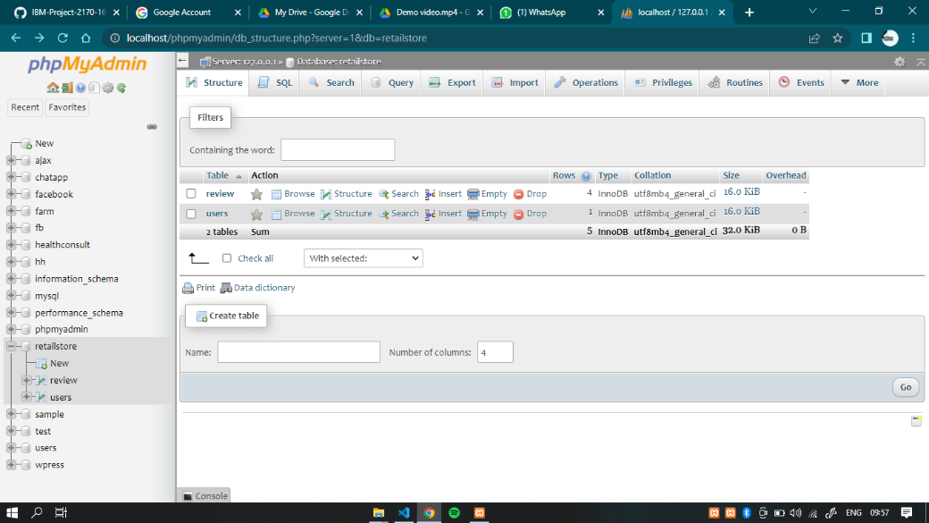

**CHAPTER 8**

**TESTING**

**8.1 Test Case:**

All Major activities of various testing level are described below:

* 1. Unit Testing
  2. Integration Testing
  3. Functional Testing
  4. System Testing
  5. White box Testing
  6. Black Box Testing

**1. Unit Testing:**

Unit testing involves the design of test cases that validate that the internal program logic is functioning properly, and that program inputs produce valid outputs. All decision branches internal code flow should be validated. It is the testing of individual software units of the application. It is done after the completion of an individual unit before integration. This is a structural testing, that relies on knowledge of its construction and is invasive.

**2. Integration Testing:**

Integration tests are designed to test integrated software components to determine if they actually run as one program. Testing is event driven and is more concerned with the basic outcome of screens or fields. Integration tests demonstrate that although the components were individually satisfaction, as shown by successfully unit testing, the combination of components is correct and consistent.

**3. Functional Testing:**

Functional tests provide systematic demonstrations that functions tested are available as specified by the business and technical requirements system documentation, and user manuals.

**4. System Testing:**

System testing ensures that the entire integrated software system meets requirements. It tests a configuration to ensure known and predictable results. An example of system testing is the configuration-oriented system integration test. System testing is based on process description and flows, emphasizing pre-driven process links and integration points.

**5. White Box Testing:**

White Box Testing is a testing in which in which the software tester has knowledge of the inner workings, structure and language of the software, oral least its purpose. It is purpose. It is used to test areas that cannot be reached from a black box level.

**8.2 User Acceptance Testing:**

User Acceptance Testing is a critical phase of any project and requires significant participant by the end user. It also ensures that the system meets the functional requirements.

**CHAPTER 9**

**RESULTS**

**9.1 Performance Metrics:**

Performance metrics are refined as figures and data representative of an organizations's actions, abilities, and overall quality.

|  |  |  |
| --- | --- | --- |
| **S.NO** | **Parameter** | **Screenshot / Values** |
| 1 | Dashboard design | Dashboard consist of 16 graph in 4 different tabs. |
| 2 | Data Responsiveness | Data was responsive for creating dashboard, story and report. |
| 3 | Amount Data to Rendered (DB2 Metrics) | Inventory management dataset which consist of 938 data in it. |
| 4 | Utilization of Data Filters | Data filters was used to find the top most of the data in form of visualization |
| 5 | Effective User Story | Story consist of 4 scenes and 5 graphs. |
| 6 | Descriptive Reports | Created 2 reports with 7 graphs. |

**Table.9.1 Performance metrics**

**CHAPTER 10**

**ADVANTAGES & DISADVANTAGES**

**Advantages:**

* Improves Accuracy
* Reduces costs
* Saves Time
* Improves Business Planning
* Improves Customer Service
* Minimized human error

**Disadvantages:**

* Set up costs
* Time-consuming process for lesser workforce
* The complexity of the system
* Depreciation, markdowns, product damage and theft can affect the price of the retail inventory.

**CHAPTER 11**

**CONCLUSION & FUTURE WORK**

**11.1 Conclusions**

Retail store inventory management is critical to efficient operations and effective cash management. It is important that you develop procedures to manage your inventory accurately and effectively. The best method for a particular business will depend on:

* The type of goods being stocked
* The level of customer demand
* The resources available to the business

To make sure that inventory is managed effectively, businesses need to have systems and processes in place to track stock levels and keep accurate records — this can be done manually or with the help of specialized purchase order software.Good retail inventory management is essential to the success of any retail business. By putting in place effective systems and processes, businesses can ensure that they have the right level of stock to meet customer demand while also avoiding excessive levels of stock that can tie up valuable resources.

**12.2 Future Scope:**

Inventory management systems have become more real-time, giving retailers more data about demographics, spending habits, shopping preferences, etc.. Stock control for omni channel retailing.Stores doing omni channel retailing are at the top of their game; they attract the 90% of consumers who switch between at least three applications per day to complete specific tasks.Inventories that power experiential retail.

**APPENDIX:**

**1. Source Code :**

**login.php:**

**<?php include('server.php') ?><?php**

**?>**

**<!DOCTYPE html>**

**<html>**

**<head>**

**<meta charset="utf-8">**

**<meta name="viewport" content="width=device-width, initial-scale=1.0">**

**<link rel="stylesheet" href="https://stackpath.bootstrapcdn.com/font-awesome/4.7.0/css/font-awesome.min.css">**

**<link rel="stylesheet" type="text/css" href="styles.css">**

**<title>Login Form</title>**

**</head>**

**<body>**

**<div class="container">**

**<form action="login.php" method="POST" class="login-email">**

**<?php include('errors.php'); ?>**

**<p class="login-text" style="font-size: 2rem; font-weight: 800;">Login</p>**

**<div class="input-group">**

**<input type="text" placeholder="username" name="username" required>**

**</div>**

**<div class="input-group">**

**<input type="password" placeholder="Password" name="password" required>**

**</div>**

**<div class="input-group">**

**<button type="submit" class="btn" name="login_user">Login</button>**

**</div>**

**<p class="login-register-text">Don't have an account? <a href="register.php">Register Here</a>.</p>**

**</form>**

**</div>**

**</body>**

**</html>**

**register.php:**

<?php include('server.php') ?>

<!DOCTYPE html>

<html>

<head>

<meta charset="utf-8">

<meta name="viewport" content="width=device-width, initial-scale=1.0">

<link rel="stylesheet" href="https://stackpath.bootstrapcdn.com/font-awesome/4.7.0/css/font-awesome.min.css">

<link rel="stylesheet" type="text/css" href="styles.css">

<title>Register Form </title>

</head>

<body>

<div class="container">

<form action="register.php" method="POST" class="login-email">

<?php include('errors.php'); ?>

<p class="login-text" style="font-size: 2rem; font-weight: 800;">Register</p>

<div class="input-group">

<input type="text" placeholder="Username" name="username" value="<?php echo $username; ?>" required>

</div>

<div class="input-group">

<input type="email" placeholder="Email" name="email" value="<?php echo $email; ?>" required>

</div>

<div class="input-group">

<input type="password" placeholder="Password" name="password_1" required>

</div>

<div class="input-group">

<input type="password" placeholder="Confirm Password" name="password_2" required>

</div>

<div class="input-group">

<button type="submit" class="btn" name="reg_user">Register</button>

</div>

<p class="login-register-text">Have an account? <a href="index.php">Login Here</a>.</p>

</form>

</div>

</body>

</html>

**Report.php:**

**<?php**

**session_start();**

**if (isset($_GET['logout'])) {**

**session_destroy();**

**unset($_SESSION['username']);**

**header("location: login.php");**

**}**

**?><!DOCTYPE html>**

**<html lang="en">**

**<head>**

**<meta charset="utf-8">**

**<meta content="width=device-width, initial-scale=1.0" name="viewport">**

**<title>Dashboard</title>**

**<meta content="" name="description">**

**<meta content="" name="keywords">**

**<!-- Favicons -->**

**<link href="assets/img/favicon.png" rel="icon">**

**<link href="assets/img/apple-touch-icon.png" rel="apple-touch-icon">**

**<!-- Google Fonts -->**

**<link href="https://fonts.gstatic.com" rel="preconnect">**

**<link href="https://fonts.googleapis.com/css?family=Open+Sans:300,300i,400,400i,600,600i,700,700i|Nunito:300,300i,400,400i,600,600i,700,700i|Poppins:300,300i,400,400i,500,500i,600,600i,700,700i" rel="stylesheet">**

**<!-- Vendor CSS Files -->**

**<link href="assets/vendor/bootstrap/css/bootstrap.min.css" rel="stylesheet">**

**<link href="assets/vendor/bootstrap-icons/bootstrap-icons.css" rel="stylesheet">**

**<link href="assets/vendor/boxicons/css/boxicons.min.css" rel="stylesheet">**

**<link href="assets/vendor/quill/quill.snow.css" rel="stylesheet">**

**<link href="assets/vendor/quill/quill.bubble.css" rel="stylesheet">**

**<link href="assets/vendor/remixicon/remixicon.css" rel="stylesheet">**

**<link href="assets/vendor/simple-datatables/style.css" rel="stylesheet">**

**<!-- Template Main CSS File -->**

**<link href="assets/css/style.css" rel="stylesheet">**

**<!-- =======================================================**

**\* Template Name: NiceAdmin - v2.4.1**

**\* Template URL: https://bootstrapmade.com/nice-admin-bootstrap-admin-html-template/**

**\* Author: BootstrapMade.com**

**\* License: https://bootstrapmade.com/license/**

**======================================================== -->**

**</head>**

**<body>**

**<!-- ======= Header ======= -->**

**<header id="header" class="header fixed-top d-flex align-items-center">**

**<div class="d-flex align-items-center justify-content-between">**

**<a href="index.html" class="logo d-flex align-items-center">**

**<img src="assets/img/logo.png" alt="">**

**<span class="d-none d-lg-block">Retail store</span>**

**</a>**

**<i class="bi bi-list toggle-sidebar-btn"></i>**

**</div><!-- End Logo -->**

**<div class="search-bar">**

**<form class="search-form d-flex align-items-center" method="POST" action="#">**

**<input type="text" name="query" placeholder="Search" title="Enter search keyword">**

**<button type="submit" title="Search"><i class="bi bi-search"></i></button>**

**</form>**

**</div><!-- End Search Bar -->**

**<nav class="header-nav ms-auto">**

**<ul class="d-flex align-items-center">**

**<li class="nav-item d-block d-lg-none">**

**<a class="nav-link nav-icon search-bar-toggle " href="#">**

**<i class="bi bi-search"></i>**

**</a>**

**</li><!-- End Search Icon-->**

**<li class="nav-item dropdown">**

**<!-- End Notification Icon -->**

**<!-- <ul class="dropdown-menu dropdown-menu-end dropdown-menu-arrow notifications">**

**<li class="dropdown-header">**

**You have 4 new notifications**

**<a href="#"><span class="badge rounded-pill bg-primary p-2 ms-2">View all</span></a>**

**</li>**

**<li>**

**<hr class="dropdown-divider">**

**</li>**

**<li class="notification-item">**

**<i class="bi bi-exclamation-circle text-warning"></i>**

**<div>**

**<h4>Lorem Ipsum</h4>**

**<p>Quae dolorem earum veritatis oditseno</p>**

**<p>30 min. ago</p>**

**</div>**

**</li>**

**<li>**

**<hr class="dropdown-divider">**

**</li>**

**<li class="notification-item">**

**<i class="bi bi-x-circle text-danger"></i>**

**<div>**

**<h4>Atque rerum nesciunt</h4>**

**<p>Quae dolorem earum veritatis oditseno</p>**

**<p>1 hr. ago</p>**

**</div>**

**</li>**

**<li>**

**<hr class="dropdown-divider">**

**</li>**

**<li class="notification-item">**

**<i class="bi bi-check-circle text-success"></i>**

**<div>**

**<h4>Sit rerum fuga</h4>**

**<p>Quae dolorem earum veritatis oditseno</p>**

**<p>2 hrs. ago</p>**

**</div>**

**</li>**

**<li>**

**<hr class="dropdown-divider">**

**</li>**

**<li class="notification-item">**

**<i class="bi bi-info-circle text-primary"></i>**

**<div>**

**<h4>Dicta reprehenderit</h4>**

**<p>Quae dolorem earum veritatis oditseno</p>**

**<p>4 hrs. ago</p>**

**</div>**

**</li>**

**<li>**

**<hr class="dropdown-divider">**

**</li>**

**<li class="dropdown-footer">**

**<a href="#">Show all notifications</a>**

**</li>**

**</ul>End Notification Dropdown Items -->**

**</li><!-- End Notification Nav -->**

**<li class="nav-item dropdown">**

**<!-- <a class="nav-link nav-icon" href="#" data-bs-toggle="dropdown">**

**<i class="bi bi-chat-left-text"></i>**

**<span class="badge bg-success badge-number">3</span>**

**</a>End Messages Icon -->**

**<ul class="dropdown-menu dropdown-menu-end dropdown-menu-arrow messages">**

**<li class="dropdown-header">**

**You have 3 new messages**

**<a href="#"><span class="badge rounded-pill bg-primary p-2 ms-2">View all</span></a>**

**</li>**

**<li>**

**<hr class="dropdown-divider">**

**</li>**

**<li class="message-item">**

**<a href="#">**

**<img src="assets/img/messages-1.jpg" alt="" class="rounded-circle">**

**<div>**

**<h4>Maria Hudson</h4>**

**<p>Velit asperiores et ducimus soluta repudiandae labore officia est ut...</p>**

**<p>4 hrs. ago</p>**

**</div>**

**</a>**

**</li>**

**<li>**

**<hr class="dropdown-divider">**

**</li>**

**<li class="message-item">**

**<a href="#">**

**<img src="assets/img/messages-2.jpg" alt="" class="rounded-circle">**

**<div>**

**<h4>Anna Nelson</h4>**

**<p>Velit asperiores et ducimus soluta repudiandae labore officia est ut...</p>**

**<p>6 hrs. ago</p>**

**</div>**

**</a>**

**</li>**

**<li>**

**<hr class="dropdown-divider">**

**</li>**

**<li class="message-item">**

**<a href="#">**

**<img src="assets/img/messages-3.jpg" alt="" class="rounded-circle">**

**<div>**

**<h4>David Muldon</h4>**

**<p>Velit asperiores et ducimus soluta repudiandae labore officia est ut...</p>**

**<p>8 hrs. ago</p>**

**</div>**

**</a>**

**</li>**

**<li>**

**<hr class="dropdown-divider">**

**</li>**

**<li class="dropdown-footer">**

**<a href="#">Show all messages</a>**

**</li>**

**</ul><!-- End Messages Dropdown Items -->**

**</li>**

**<li class="nav-item dropdown pe-3">**

**<a class="nav-link nav-profile d-flex align-items-center pe-0" href="#" data-bs-toggle="dropdown">**

**<img src="assets/img/1.jpg" alt="Profile" class="rounded-circle">**

**<span class="d-none d-md-block dropdown-toggle ps-2"><?php $_SESSION['username']?></span>**

**</a><!-- End Profile Iamge Icon -->**

**<ul class="dropdown-menu dropdown-menu-end dropdown-menu-arrow profile">**

**<li class="dropdown-header">**

**<h6> <?php echo $_SESSION['username']; ?></h6>**

**<span></span>**

**</li>**

**<li>**

**<hr class="dropdown-divider">**

**</li>**

**<li>**

**<a class="dropdown-item d-flex align-items-center" href="users-profile.php">**

**<i class="bi bi-person"></i>**

**<span>My Profile</span>**

**</a>**

**</li>**

**<li>**

**<hr class="dropdown-divider">**

**</li>**

**<li>**

**<a class="dropdown-item d-flex align-items-center" href="users-profile.html">**

**<i class="bi bi-gear"></i>**

**<span>Account Settings</span>**

**</a>**

**</li>**

**<li>**

**<hr class="dropdown-divider">**

**</li>**

**<li>**

**<a class="dropdown-item d-flex align-items-center" href="pages-faq.html">**

**<i class="bi bi-question-circle"></i>**

**<span>Need Help?</span>**

**</a>**

**</li>**

**<li>**

**<hr class="dropdown-divider">**

**</li>**

**<li>**

**<a class="dropdown-item d-flex align-items-center" href="<?php if($_SESSION['username']){**

**echo "login.php";}?>">**

**<?php if(!$_SESSION['username']){?>**

**<i class="bi bi-box-arrow-right"></i>**

**<span>**

**<?php echo"Login";?></span>**

**<?php }else{?>**

**<i class="bi bi-box-arrow-right"></i>**

**<?php echo"Logout";**

**}?>**

**</a>**

**</li>**

**</ul><!-- End Profile Dropdown Items -->**

**</li><!-- End Profile Nav -->**

**</ul>**

**</nav><!-- End Icons Navigation -->**

**</header><!-- End Header -->**

**<!-- ======= Sidebar ======= -->**

**<aside id="sidebar" class="sidebar">**

**<ul class="sidebar-nav" id="sidebar-nav">**

**<li class="nav-item">**

**<a class="nav-link " href="index.php">**

**<i class="bi bi-grid"></i>**

**<span>Dashboard</span>**

**</a>**

**</li>**

**<li class="nav-item">**

**<a class="nav-link " href="Report.php">**

**<i class="bi bi-bookmark"></i>**

**<span>Report</span>**

**</a>**

**</li><!--End Dashboard Nav -->**

**<li class="nav-item">**

**<a class="nav-link " href="story.php">**

**<i class="bi bi-camera-video"></i>**

**<span>Story</span>**

**</a>**

**</li>**

**<li class="nav-heading">Pages</li>**

**<li class="nav-item">**

**<a class="nav-link collapsed" href="users-profile.php">**

**<i class="bi bi-person"></i>**

**<span>Profile</span>**

**</a>**

**</li><!-- End Profile Page Nav -->**

**<li class="nav-item">**

**<a class="nav-link collapsed" href="contact.php">**

**<i class="bi bi-envelope"></i>**

**<span>Contact</span>**

**</a>**

**</li><!-- End Contact Page Nav -->**

**<li class="nav-item">**

**<a class="nav-link collapsed" href="pages-register.html">**

**<i class="bi bi-card-list"></i>**

**<span>About</span>**

**</a>**

**</li><!-- End Register Page Nav -->**

**<li class="nav-item">**

**<a class="nav-link collapsed" href="index.php?logout='1'\">**

**<i class="bi bi-box-arrow-in-right"></i>**

**<?php if(!$_SESSION['username']){?>**

**<i class="bi bi-question-circle"></i>**

**<span>**

**<?php echo"Login";?></span>**

**<?php }else{echo"Logout";**

**}?>**

**</a>**

**</li><!-- End Login Page Nav -->**

**</ul>**

**</aside><!-- End Sidebar-->**

**<main id="main" class="main">**

**<div class="pagetitle">**

**<h1>Report</h1>**

**<nav>**

**<ol class="breadcrumb">**

**<li class="breadcrumb-item"><a href="index.html">Home</a></li>**

**<li class="breadcrumb-item active">Report</li>**

**</ol>**

**</nav>**

**</div><!-- End Page Title -->**

**<section class="section dashboard">**

**<div class="row">**

**<!-- Left side columns -->**

**<div class="col-lg-8">**

**<div class="row">**

**</div>**

**</div><!-- End Left side columns -->**

**<!-- -->**

**<iframe src="https://us3.ca.analytics.ibm.com/bi/?pathRef=.my_folders%2FRetail%2BStore%2BAnalysis%2BReport&amp;closeWindowOnLastView=true&amp;ui_appbar=false&amp;ui_navbar=false&amp;shareMode=embedded&amp;action=run&amp;format=HTML&amp;prompt=false" width="1000" height="600" frameborder="0" gesture="media" allow="encrypted-media" allowfullscreen=""></iframe>**

**</section>**

**</main><!-- End #main -->**

**<!-- ======= Footer ======= -->**

**<footer id="footer" class="footer">**

**<div class="copyright">**

**&copy; Copyright <strong><span>Retail Stockers</span></strong>. All Rights Reserved**

**</div>**

**<div class="credits">**

**<!-- All the links in the footer should remain intact. -->**

**<!-- You can delete the links only if you purchased the pro version. -->**

**<!-- Licensing information: https://bootstrapmade.com/license/ -->**

**<!-- Purchase the pro version with working PHP/AJAX contact form: https://bootstrapmade.com/nice-admin-bootstrap-admin-html-template/ -->**

**Designed by <a href="https://bootstrapmade.com/">GD</a>**

**</div>**

**</footer><!-- End Footer -->**

**<a href="#" class="back-to-top d-flex align-items-center justify-content-center"><i class="bi bi-arrow-up-short"></i></a>**

**<!-- Vendor JS Files -->**

**<script src="assets/vendor/apexcharts/apexcharts.min.js"></script>**

**<script src="assets/vendor/bootstrap/js/bootstrap.bundle.min.js"></script>**

**<script src="assets/vendor/chart.js/chart.min.js"></script>**

**<script src="assets/vendor/echarts/echarts.min.js"></script>**

**<script src="assets/vendor/quill/quill.min.js"></script>**

**<script src="assets/vendor/simple-datatables/simple-datatables.js"></script>**

**<script src="assets/vendor/tinymce/tinymce.min.js"></script>**

**<script src="assets/vendor/php-email-form/validate.js"></script>**

**<!-- Template Main JS File -->**

**<script src="assets/js/main.js"></script>**

**</body>**

**</html>**

**story.php:**

**<?php**

**session_start();**

**if (isset($_GET['logout'])) {**

**session_destroy();**

**unset($_SESSION['username']);**

**header("location: login.php");**

**}**

**?><!DOCTYPE html>**

**<html lang="en">**

**<head>**

**<meta charset="utf-8">**

**<meta content="width=device-width, initial-scale=1.0" name="viewport">**

**<title>Dashboard</title>**

**<meta content="" name="description">**

**<meta content="" name="keywords">**

**<!-- Favicons -->**

**<link href="assets/img/favicon.png" rel="icon">**

**<link href="assets/img/apple-touch-icon.png" rel="apple-touch-icon">**

**<!-- Google Fonts -->**

**<link href="https://fonts.gstatic.com" rel="preconnect">**

**<link href="https://fonts.googleapis.com/css?family=Open+Sans:300,300i,400,400i,600,600i,700,700i|Nunito:300,300i,400,400i,600,600i,700,700i|Poppins:300,300i,400,400i,500,500i,600,600i,700,700i" rel="stylesheet">**

**<!-- Vendor CSS Files -->**

**<link href="assets/vendor/bootstrap/css/bootstrap.min.css" rel="stylesheet">**

**<link href="assets/vendor/bootstrap-icons/bootstrap-icons.css" rel="stylesheet">**

**<link href="assets/vendor/boxicons/css/boxicons.min.css" rel="stylesheet">**

**<link href="assets/vendor/quill/quill.snow.css" rel="stylesheet">**

**<link href="assets/vendor/quill/quill.bubble.css" rel="stylesheet">**

**<link href="assets/vendor/remixicon/remixicon.css" rel="stylesheet">**

**<link href="assets/vendor/simple-datatables/style.css" rel="stylesheet">**

**<!-- Template Main CSS File -->**

**<link href="assets/css/style.css" rel="stylesheet">**

**<!-- =======================================================**

**\* Template Name: NiceAdmin - v2.4.1**

**\* Template URL: https://bootstrapmade.com/nice-admin-bootstrap-admin-html-template/**

**\* Author: BootstrapMade.com**

**\* License: https://bootstrapmade.com/license/**

**======================================================== -->**

**</head>**

**<body>**

**<!-- ======= Header ======= -->**

**<header id="header" class="header fixed-top d-flex align-items-center">**

**<div class="d-flex align-items-center justify-content-between">**

**<a href="index.html" class="logo d-flex align-items-center">**

**<img src="assets/img/logo.png" alt="">**

**<span class="d-none d-lg-block">Retail store</span>**

**</a>**

**<i class="bi bi-list toggle-sidebar-btn"></i>**

**</div><!-- End Logo -->**

**<div class="search-bar">**

**<form class="search-form d-flex align-items-center" method="POST" action="#">**

**<input type="text" name="query" placeholder="Search" title="Enter search keyword">**

**<button type="submit" title="Search"><i class="bi bi-search"></i></button>**

**</form>**

**</div><!-- End Search Bar -->**

**<nav class="header-nav ms-auto">**

**<ul class="d-flex align-items-center">**

**<li class="nav-item d-block d-lg-none">**

**<a class="nav-link nav-icon search-bar-toggle " href="#">**

**<i class="bi bi-search"></i>**

**</a>**

**</li><!-- End Search Icon-->**

**<li class="nav-item dropdown">**

**<!-- End Notification Icon -->**

**<!-- <ul class="dropdown-menu dropdown-menu-end dropdown-menu-arrow notifications">**

**<li class="dropdown-header">**

**You have 4 new notifications**

**<a href="#"><span class="badge rounded-pill bg-primary p-2 ms-2">View all</span></a>**

**</li>**

**<li>**

**<hr class="dropdown-divider">**

**</li>**

**<li class="notification-item">**

**<i class="bi bi-exclamation-circle text-warning"></i>**

**<div>**

**<h4>Lorem Ipsum</h4>**

**<p>Quae dolorem earum veritatis oditseno</p>**

**<p>30 min. ago</p>**

**</div>**

**</li>**

**<li>**

**<hr class="dropdown-divider">**

**</li>**

**<li class="notification-item">**

**<i class="bi bi-x-circle text-danger"></i>**

**<div>**

**<h4>Atque rerum nesciunt</h4>**

**<p>Quae dolorem earum veritatis oditseno</p>**

**<p>1 hr. ago</p>**

**</div>**

**</li>**

**<li>**

**<hr class="dropdown-divider">**

**</li>**

**<li class="notification-item">**

**<i class="bi bi-check-circle text-success"></i>**

**<div>**

**<h4>Sit rerum fuga</h4>**

**<p>Quae dolorem earum veritatis oditseno</p>**

**<p>2 hrs. ago</p>**

**</div>**

**</li>**

**<li>**

**<hr class="dropdown-divider">**

**</li>**

**<li class="notification-item">**

**<i class="bi bi-info-circle text-primary"></i>**

**<div>**

**<h4>Dicta reprehenderit</h4>**

**<p>Quae dolorem earum veritatis oditseno</p>**

**<p>4 hrs. ago</p>**

**</div>**

**</li>**

**<li>**

**<hr class="dropdown-divider">**

**</li>**

**<li class="dropdown-footer">**

**<a href="#">Show all notifications</a>**

**</li>**

**</ul>End Notification Dropdown Items -->**

**</li><!-- End Notification Nav -->**

**<li class="nav-item dropdown">**

**<!-- <a class="nav-link nav-icon" href="#" data-bs-toggle="dropdown">**

**<i class="bi bi-chat-left-text"></i>**

**<span class="badge bg-success badge-number">3</span>**

**</a>End Messages Icon -->**

**<ul class="dropdown-menu dropdown-menu-end dropdown-menu-arrow messages">**

**<li class="dropdown-header">**

**You have 3 new messages**

**<a href="#"><span class="badge rounded-pill bg-primary p-2 ms-2">View all</span></a>**

**</li>**

**<li>**

**<hr class="dropdown-divider">**

**</li>**

**<li class="message-item">**

**<a href="#">**

**<img src="assets/img/messages-1.jpg" alt="" class="rounded-circle">**

**<div>**

**<h4>Maria Hudson</h4>**

**<p>Velit asperiores et ducimus soluta repudiandae labore officia est ut...</p>**

**<p>4 hrs. ago</p>**

**</div>**

**</a>**

**</li>**

**<li>**

**<hr class="dropdown-divider">**

**</li>**

**<li class="message-item">**

**<a href="#">**

**<img src="assets/img/messages-2.jpg" alt="" class="rounded-circle">**

**<div>**

**<h4>Anna Nelson</h4>**

**<p>Velit asperiores et ducimus soluta repudiandae labore officia est ut...</p>**

**<p>6 hrs. ago</p>**

**</div>**

**</a>**

**</li>**

**<li>**

**<hr class="dropdown-divider">**

**</li>**

**<li class="message-item">**

**<a href="#">**

**<img src="assets/img/messages-3.jpg" alt="" class="rounded-circle">**

**<div>**

**<h4>David Muldon</h4>**

**<p>Velit asperiores et ducimus soluta repudiandae labore officia est ut...</p>**

**<p>8 hrs. ago</p>**

**</div>**

**</a>**

**</li>**

**<li>**

**<hr class="dropdown-divider">**

**</li>**

**<li class="dropdown-footer">**

**<a href="#">Show all messages</a>**

**</li>**

**</ul><!-- End Messages Dropdown Items -->**

**</li>**

**<li class="nav-item dropdown pe-3">**

**<a class="nav-link nav-profile d-flex align-items-center pe-0" href="#" data-bs-toggle="dropdown">**

**<img src="assets/img/1.jpg" alt="Profile" class="rounded-circle">**

**<span class="d-none d-md-block dropdown-toggle ps-2"><?php $_SESSION['username']?></span>**

**</a><!-- End Profile Iamge Icon -->**

**<ul class="dropdown-menu dropdown-menu-end dropdown-menu-arrow profile">**

**<li class="dropdown-header">**

**<h6> <?php echo $_SESSION['username']; ?></h6>**

**<span></span>**

**</li>**

**<li>**

**<hr class="dropdown-divider">**

**</li>**

**<li>**

**<a class="dropdown-item d-flex align-items-center" href="users-profile.php">**

**<i class="bi bi-person"></i>**

**<span>My Profile</span>**

**</a>**

**</li>**

**<li>**

**<hr class="dropdown-divider">**

**</li>**

**<li>**

**<a class="dropdown-item d-flex align-items-center" href="users-profile.html">**

**<i class="bi bi-gear"></i>**

**<span>Account Settings</span>**

**</a>**

**</li>**

**<li>**

**<hr class="dropdown-divider">**

**</li>**

**<li>**

**<a class="dropdown-item d-flex align-items-center" href="pages-faq.html">**

**<i class="bi bi-question-circle"></i>**

**<span>Need Help?</span>**

**</a>**

**</li>**

**<li>**

**<hr class="dropdown-divider">**

**</li>**

**<li>**

**<a class="dropdown-item d-flex align-items-center" href="<?php if($_SESSION['username']){**

**echo "login.php";}?>">**

**<?php if(!$_SESSION['username']){?>**

**<i class="bi bi-box-arrow-right"></i>**

**<span>**

**<?php echo"Login";?></span>**

**<?php }else{?>**

**<i class="bi bi-box-arrow-right"></i>**

**<?php echo"Logout";**

**}?>**

**</a>**

**</li>**

**</ul><!-- End Profile Dropdown Items -->**

**</li><!-- End Profile Nav -->**

**</ul>**

**</nav><!-- End Icons Navigation -->**

**</header><!-- End Header -->**

**<!-- ======= Sidebar ======= -->**

**<aside id="sidebar" class="sidebar">**

**<ul class="sidebar-nav" id="sidebar-nav">**

**<li class="nav-item">**

**<a class="nav-link " href="index.php">**

**<i class="bi bi-grid"></i>**

**<span>Dashboard</span>**

**</a>**

**</li>**

**<li class="nav-item">**

**<a class="nav-link " href="Report.php">**

**<i class="bi bi-bookmark"></i>**

**<span>Report</span>**

**</a>**

**</li><!--End Dashboard Nav -->**

**<li class="nav-item">**

**<a class="nav-link " href="story.php">**

**<i class="bi bi-camera-video"></i>**

**<span>Story</span>**

**</a>**

**</li>**

**<li class="nav-heading">Pages</li>**

**<li class="nav-item">**

**<a class="nav-link collapsed" href="users-profile.php">**

**<i class="bi bi-person"></i>**

**<span>Profile</span>**

**</a>**

**</li><!-- End Profile Page Nav -->**

**<li class="nav-item">**

**<a class="nav-link collapsed" href="contact.php">**

**<i class="bi bi-envelope"></i>**

**<span>Contact</span>**

**</a>**

**</li><!-- End Contact Page Nav -->**

**<li class="nav-item">**

**<a class="nav-link collapsed" href="pages-register.html">**

**<i class="bi bi-card-list"></i>**

**<span>About</span>**

**</a>**

**</li><!-- End Register Page Nav -->**

**<li class="nav-item">**

**<a class="nav-link collapsed" href="index.php?logout='1'\">**

**<i class="bi bi-box-arrow-in-right"></i>**

**<?php if(!$_SESSION['username']){?>**

**<i class="bi bi-question-circle"></i>**

**<span>**

**<?php echo"Login";?></span>**

**<?php }else{echo"Logout";**

**}?>**

**</a>**

**</li><!-- End Login Page Nav -->**

**</ul>**

**</aside><!-- End Sidebar-->**

**<main id="main" class="main">**

**<div class="pagetitle">**

**<h1>Story</h1>**

**<nav>**

**<ol class="breadcrumb">**

**<li class="breadcrumb-item"><a href="index.html">Home</a></li>**

**<li class="breadcrumb-item active">Story</li>**

**</ol>**

**</nav>**

**</div><!-- End Page Title -->**

**<section class="section dashboard">**

**<div class="row">**

**<!-- Left side columns -->**

**<div class="col-lg-8">**

**<div class="row">**

**</div>**

**</div><!-- End Left side columns -->**

**<!-- -->**

**<iframe src="https://us3.ca.analytics.ibm.com/bi/?perspective=story&amp;pathRef=.my_folders%2FRetail%2BStore%2BInventory%2BStory&amp;closeWindowOnLastView=true&amp;ui_appbar=false&amp;ui_navbar=false&amp;shareMode=embedded&amp;action=view&amp;sceneId=model000001848a560f0d_00000000&amp;sceneTime=0" width="1000" height="600" frameborder="0" gesture="media" allow="encrypted-media" allowfullscreen=""></iframe>**

**</section>**

**</main><!-- End #main -->**

**<!-- ======= Footer ======= -->**

**<footer id="footer" class="footer">**

**<div class="copyright">**

**&copy; Copyright <strong><span>Retail Stockers</span></strong>. All Rights Reserved**

**</div>**

**<div class="credits">**

**<!-- All the links in the footer should remain intact. -->**

**<!-- You can delete the links only if you purchased the pro version. -->**

**<!-- Licensing information: https://bootstrapmade.com/license/ -->**

**<!-- Purchase the pro version with working PHP/AJAX contact form: https://bootstrapmade.com/nice-admin-bootstrap-admin-html-template/ -->**

**Designed by <a href="https://bootstrapmade.com/">GD</a>**

**</div>**

**</footer><!-- End Footer -->**

**<a href="#" class="back-to-top d-flex align-items-center justify-content-center"><i class="bi bi-arrow-up-short"></i></a>**

**<!-- Vendor JS Files -->**

**<script src="assets/vendor/apexcharts/apexcharts.min.js"></script>**

**<script src="assets/vendor/bootstrap/js/bootstrap.bundle.min.js"></script>**

**<script src="assets/vendor/chart.js/chart.min.js"></script>**

**<script src="assets/vendor/echarts/echarts.min.js"></script>**

**<script src="assets/vendor/quill/quill.min.js"></script>**

**<script src="assets/vendor/simple-datatables/simple-datatables.js"></script>**

**<script src="assets/vendor/tinymce/tinymce.min.js"></script>**

**<script src="assets/vendor/php-email-form/validate.js"></script>**

**<!-- Template Main JS File -->**

**<script src="assets/js/main.js"></script>**

**</body>**

**</html>**

1. **Github Link:**

[**https://github.com/IBM-EPBL/IBM-Project-2170-1658464871**](https://github.com/IBM-EPBL/IBM-Project-2170-1658464871)

1. **Project Demo Link:**

[**https://drive.google.com/file/d/1o5jtd_UM8nqXTQuD8AC8kdaNCK-4z0y_/view?usp=sharing**](https://drive.google.com/file/d/1o5jtd_UM8nqXTQuD8AC8kdaNCK-4z0y_/view?usp=sharing)